To show off what I can do Software Development, I have written a simple program that lets me take information from a webpage, such as this version of the poem The Raven.

I then run it through some processing,

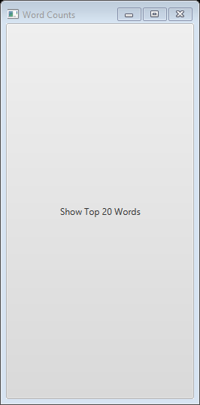

And that lets me determine what the most common words are to appear in the poem.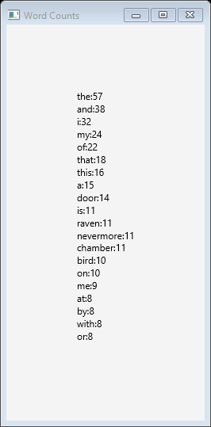

All code can be found on my GitHub:  
<https://github.com/splatterfest233/Software-Development-Class>